**SWE 645 Assignment-1**

**Vamsi Krishna Maram, G01478991**

**PART-1: Steps to Host website in S3 Bucket:**

1. Create a bucket, enter the bucket name, choose the region, and accept default settings.
2. Enable static website hosting by going to **Properties** → **Static website hosting** → **Edit**, and select the option to host a website. Enter the index and error document names, then save.
3. Edit block public access settings by selecting the bucket, go to **Permissions** → **Block public access** → **Edit**. Uncheck "Block all public access" and save.
4. Add a bucket policy to make the content public. Go to **Permissions** → **Bucket Policy** → **Edit**, and write a policy for public read access. Save the changes.
5. To get public, read access to our website, write Bucket policy code in editor:

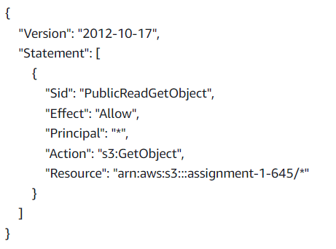

Select the save changes.

1. Open the bucket and upload all the required files(index.html, error.html, img.jpg, logo.jpg)

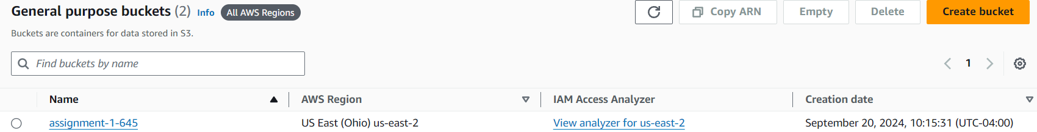

**Class Page link:** http://assignment-1-645.s3-website.us-east-2.amazonaws.com/

**Error Page link:** http://assignment-1-645.s3-website.us-east-2.amazonaws.com/error.html

**PART-2: Steps to configure EC2 instance:**

1. In AWS console, select EC2 service.
2. In EC2, select launch instance.
3. Give instance name and AMI.(Instance name: 645-hw1, AMI: ubuntu)
4. Now, create a key pair with key name and RSA keypair type with .ppk as private key file format and download it to local system.(key name: vamsi.ppk)
5. Now, add HTTP and HTTPS security groups.
6. Select the launch instance to create EC2 instance.
7. Now, connect to the EC2 instance using connect option.
8. In the console, we will use apache web server for the ubuntu.

Commands to install apache are:

1) sudo apt update

2) sudo apt install -y apache2

3) sudo systemctl start apache2

4) sudo systemctl enable apache2.

Commands to get write access to var/www/html are:

1. sudo chown -R -v ubuntu /var/www/html
2. chmod 777 /var/www/html

**Steps to upload survey form:**

1. Install WinSCP
2. Now, Connect to WinSCP with hostname and username(hostname: public IPV4 adress and username:ubuntu)
3. Go to Advanced settings, on Private key file, upload the .ppk file that we downloaded from EC2 instance(file name:vamsi.ppk) and select login
4. Upload survey.html file to /var/www/html directory, from local system to remote.

Now, go to EC2 instance, select the Public IPV4 DNS link and change https to http and add /servey.html to open the file



**Survey Page link:** http://ec2-3-144-33-170.us-east-2.compute.amazonaws.com/survey.html